25th Annual Wachusett Mountain Race
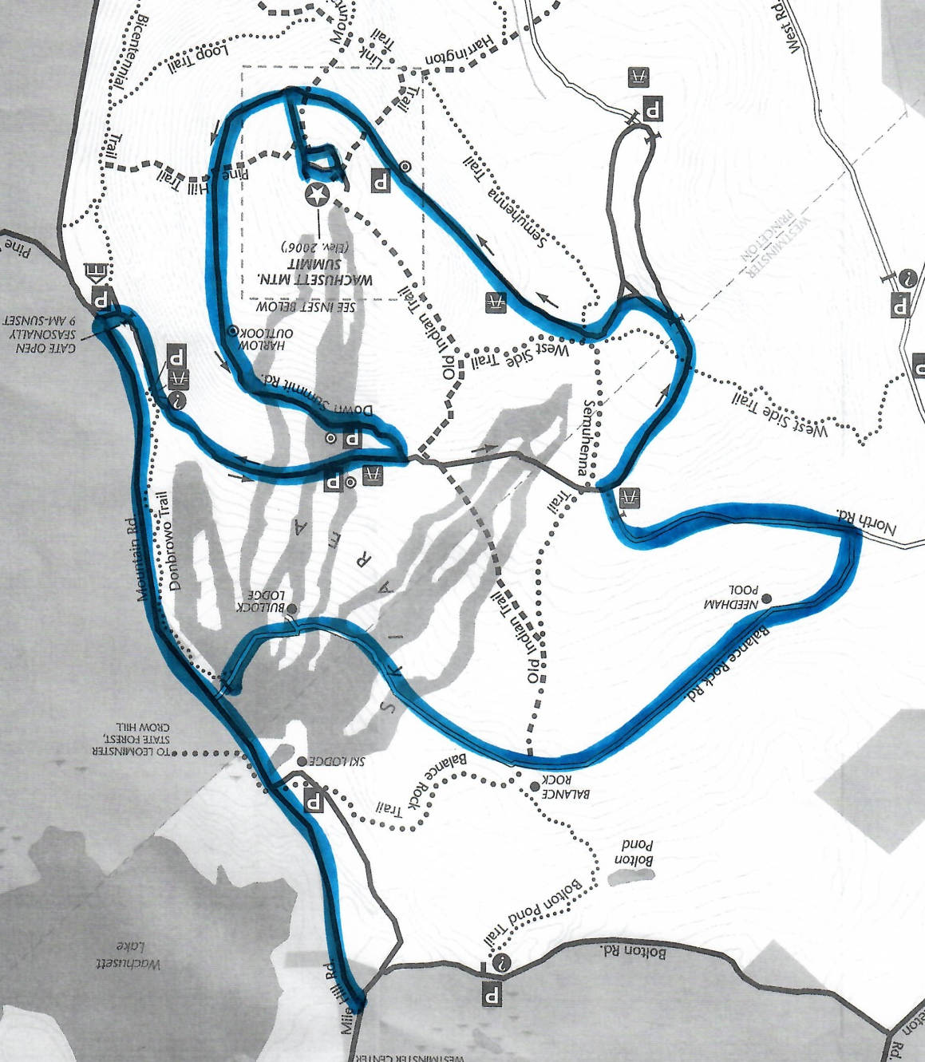
FINISH

10K
START

RACE COURSE
The Race Begins at the bottom of Mile Hill Road at the junction of Boulton Road. The race goes uphill 1.2 miles to the DCR Visitors Center entrance where the race turns right. The race goes thru the gate on the right onto Summit Road.
Water Stop 1 will be on Summit road just after the gate. The race continues up the Summit road and turns left to go UP the Down Road to the summit.
Water Stop 2 will be at the entrance to the summit. The race will go over the top and go up walkway near observation tower and back thru the parking area and loop back through Water Stop 2. The race will turn right off the summit and continue Down the Up Road.
Water Stop 3 will be at the intersection of the Summit road and North Road. The race will take a left down North Road which is gravel.
The race will turn right on to Balance Rock Road and will continue down to the rear of the Lodge and to the finish line.

DISCLAIMER: Course subject to change for the safety of all involved
= Water Stop = Police Detail

